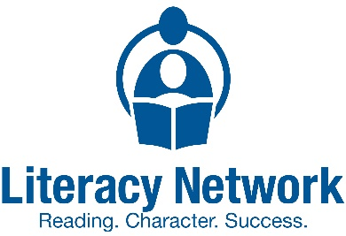
Literacy Network of Greater Cincinnati
The Literacy Network of Greater Cincinnati champions the development of literacy in the individual, the family, the workplace, the school, and the community by raising awareness, improving access, and serving as a catalyst for literacy efforts.

Book Drive Tool Kit
Thank you for hosting a book drive to support the Literacy Network!
Attached you will find the following items to make your book drive run smoothly
and create as little work as possible for you, the organizer!

Your Tool Kit includes:
• Commonly asked questions
• Statistics on the need for books
• Flyers/Posters
• Signage for your donation bin

Commonly asked questions
What types of books should I collect?
Our critical need is new and gently used elementary aged books, k-6th grade reading level and books showing diversity. We cannot accept adult books, magazines, textbooks, encyclopedias, coloring books or highly damaged books.
Can I collect used books?
Yes! We accept new and gently used books in good condition and are especially in need of early reader books that show diversity.
How long should my book drive last?
We suggest running your book drive for at least a week to give your audience a chance to see your publicity and round up their books to donate.
How can I make my book drive a success?
We recommend promoting your book drive starting at least two weeks in advance via whatever media works best for you: posters, eblasts, newsletters, social media, company intranet, school announcements, flyers etc. Continue to remind your potential givers about the book drive in the days leading up to it and throughout its duration. If you are a business and your collection bins will be in public spaces, consider a press release to spread the word.
What if someone wants to make a monetary donation?
We are thankful for all donations. People who wish to donate money can do so online at https://www.lngc.org/donate or by mail to 635 W 7th St., Suite 309, Cincinnati, OH 45203
What kind of collection bin should I use?
We recommend small to medium size cardboard boxes but whatever you have available can work. Just keep in mind if the box/bag it too large it becomes very difficult to transport and carry. If you can sort the books by grade level, please note the level on the outside of the box. You can use the printable flyers/signs in this tool kit to decorate the bins or make your own.
Do I need to sort the books at the end of the book drive?
If you have the time and capacity it is great if you can sort the books by grade level. If not, we can sort them back at our office. Please remove and recycle any books that are in bad shape (torn pages, written in, ripped covers, or broken spines) before boxing the books.

How do I get the books to the Literacy Network?
Once the books are packed in boxes, they are ready to go to the Literacy Network! Arrange a day and time for delivery of the books by emailing Liz Asman at liz.asman@lngc.org.
Should I do any follow-up at the end of my book drive?
Send the Literacy Network photos, how many books you received and details of the event so we can share your success! If you post any photo’s during the book drive please tag us @LiteracyCincy on Facebook.

Thank you for holding a book drive for the Literacy Network!

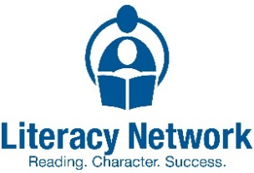

Statistics on lack of book access, the benefits of books in the home and the value of reading to your child...
*Please use the below stats to help encourage book donations by educating your audience.

- In middle-income neighborhoods the ratio of books per child is 13 to 1, in low-income neighborhoods, the ratio is 1 age-appropriate book for every 300 children. Neuman, Susan B. and David K. Dickinson, ed. Handbook of Early Literacy Research, Volume 2. New York, NY: 2006, p. 31
- 61% of low-income families have no books at all in their homes for their children. Reading Literacy in the United States: Findings from the IEA Reading Literacy Study. (1996).
- The single most significant factor influencing a child’s early educational success is an introduction to books and being read to at home prior to beginning school. National Commission on Reading, 1985
- The only behavior measure that correlates significantly with reading scores is the number of books in the home. The Literacy Crisis: False Claims, Real Solutions, 1998
- The most successful way to improve the reading achievement of low-income children is to increase their access to print. Newman, Sanford, et all. “American’s Child Care Crisis: A Crime Prevention Tragedy”; Fight Crime: Invest in Kids, 2000.
- Children who live in print-rich environments and who are read to during the first years of life are much more likely to learn to read on schedule. Southern Early Childhood Association, “Making Books Part of a Healthy Childhood.”
- Children with greater access to books and other print materials express more enjoyment of books, reading, and academics. Children’s Access to Print Material and Education Related Outcomes.
- Children growing up in homes with at least twenty books get three years more schooling than children from bookless homes, independent of their parents’ education, occupation, and class. Evans, M. D., Kelley, J., Sikora, J., & Treiman, D. J. (2010). Family scholarly culture and educational success: Books and schooling in 27 nations. Research in Social Stratification and Mobility, 28(2), 171-197.
KIDS’ BOOK DRIVE
For kids in need in Greater Cincinnati
We need Books! Lots of Books!
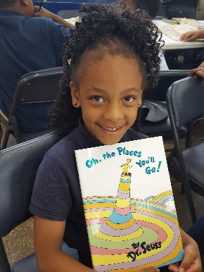
Donate new or gently used books.
Board books. Picture books. Beginning Readers (k-6^{th)}.
Books featuring diversity are especially needed.

Book donations will be accepted during these dates: ________________________________________
Collection boxes will be located:_________________________________________________________
Questions? Contact Person:_____________________________________________________________
All books should be in good condition (new or gently used).
Books will be distributed to children in low-income families in Cincinnati.
We cannot accept books for adults, magazines, textbooks, encyclopedia sets, coloring books, etc.

THANK YOU!
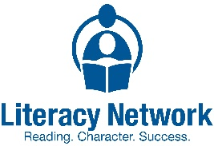

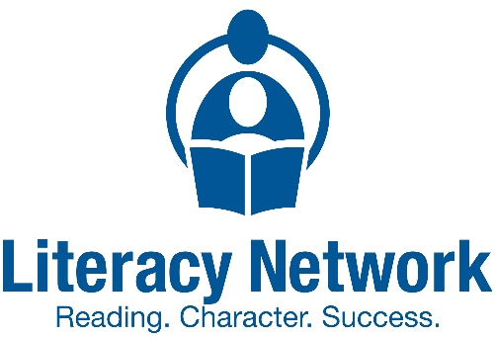

Insert your logo and or information here

DONATE CHILDRENS’ BOOKS!
Help us put books in the hands of families in need.
The Literacy Network of greater Cincinnati needs elementary age books, grade level k-6th.
We are collecting gently used & new books from [DATE] to [DATE]. For more info contact, [organizer] at [phone #]. You can drop the books off at [Drop off location].
Learn more about the Literacy Network of Greater Cincinnati at www.lngc.org
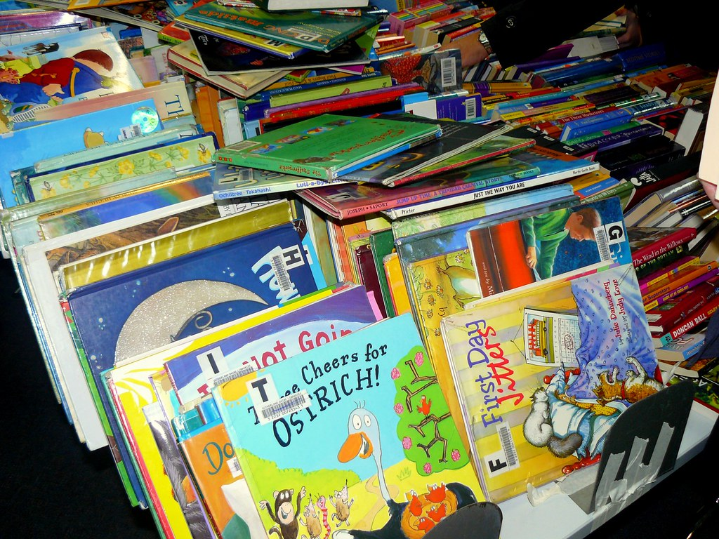

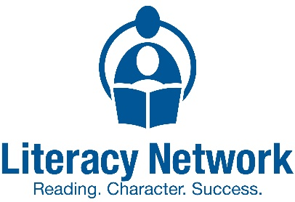
DONATE
KIDS’ BOOKS HERE

